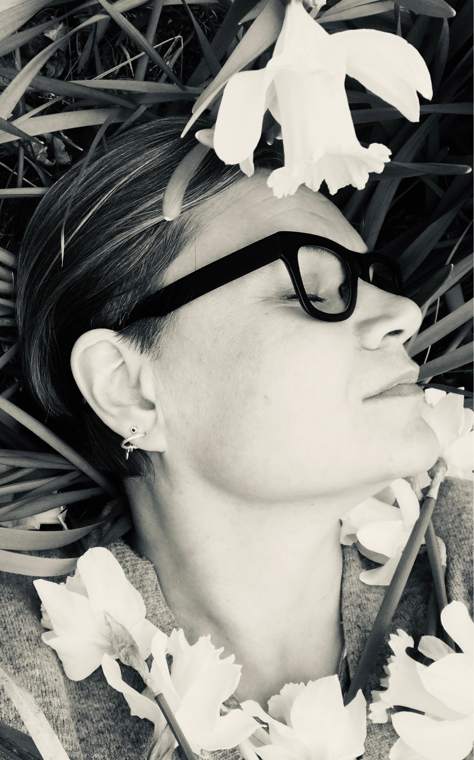
Petra Katriina Kallio
1970
Master of arts, printmaker, artist, art educator
Selected
EDUCA TION
Master of Culture and Arts studies, Turku University of Applied sciences 2016 Master of Arts, University of Art and Design, Helsinki, 2006
art teacher, Lahti University of Applied Sciences, Institute of Design and Fine Arts, Lahti, 1998 goldsmith, Lahti University of Applied Sciences, Institute of Design and Fine Arts, Lahti, 1997 designer, College of applied arts, Rovaniemi, 1995
MEMBERSHIPS
STG, Turku Graphic Artists association 2016- (chairman 2019), Turku artists association 2013 Salo artists association 2006 Art teachers association Finland 2006 Arkipelag Workshop art organisation 2006, AiA-artists of archipelago
SOLO EXHIBITIONS
2020 Hehku, Kaarinatalo, Kaarina, 2019 Hehku, Galleria Becker, Jyväskylä, 2018 Aedes Pulvis, Galleria Joella, Turku 2017 Kesäyö, Galleria Kettu, Sauvo , 2016 Teijon Masuuni, Salo, 2012 Knut -Solmuja, Helsingholm, Kemiö 2012 Solmuja ja solmukohtia, Teijo, Salo 2012 Solmuja, Sinisimpukka nature center, Kemiö 2008 Pala taivasta - pala maata, Kirakka, Perniö 2008 Viimeinen laidun, lehmään peilattu luontosuhde, Lasipalatsi, Helsinki 2006 Viimeinen laidun -lehmään peilattu luontosuhde, Villa Lande, Kemiö 1999 Adalmiinan helmi, Galleria 1, Turku 1992 Unen Kuvat, Galleria Rake, Helsinki
GROUPEXHIBITIONS (Juryed)
2019 International Biennal Print Exhibit: 2019 ROC Taiwan, 2019 International Print Biennial, Yerevan (J), 2019 “With Love” Turun Taidegraafikot ry, Galleria Joella (J), 2019 Vireä Strömfors, Ruotsinpyhtää, 2019 Turku artists association , St Karins (J), Salon Taiteilijaseuran vuosinäyttely, Kiskon kivimakasiini 2019 (J), 2019 Turun Taidegraafikot ry, Greetings from Turku, Islensk Grafik Grafiksalurinn, Reykjavik (J) 2018 TTS summer exhibition Turku, 2018 Salon Taiteilijaseuran 50-vuotisjuhlanäyttely, 2018 I Santi di Diso Engraving Prize competition, Lecce, Italy, 2017 International Print Biennial Lodz, Poland (J), 2017 The 3rd Awagami International Miniature Print Exhibition (AIMPE), 2017 Turun Taidegraafikoiden vaihtonäyttely, Grafiikka-­‐ja valokuvakeskus Ratamo, Jyväskylä , 2017 Turun Taidegraafikoiden YHTEISPAINO – kesänäyttely Galleria Joella ,Turku, 2017 Ajankuva, Kuusiston Taidekartano, Kaarina 10.6-20.8 (J), 2017 MiniPrint de Cadaqués Spain, 2016 Neo: Print Prize Bolton U.K. (J), 2016 International Biennal Print Exhibit: 2016 ROC Taiwan (J), 2016 Il Luce II, International exhibition of printmaking, Köysirata Gallery, Turku, 2016 VALO, Arkipelag Workshop ry, Gallery Pirkko-Liisa Topelius, Helsinki__2015 Hehkuvaa, Turku artists association, Haihara art center, Tampere (J) 2015 Luci Finnica, Fondanzione de Il Bisonte, Firenze Italy 2015 Länsituulta, Vaasa Art society, Seinäjoki arthall, (J) 2015 Läheltä, groupexhibition, Galleria Focus, Karjaa 2015 Turku artists association, Galleria Å, Turku 2014 Virtaa, Turku artists association, Turun raatihuoneen galleria (J) 2014 Mielen tila, Atelje Tjudapedagogi, Teijo (J) 2014, Miniprint Finland, Lahti, (J) 2013 Seuralaiset, Salo artists association, Perniö (J) 2013 Pinnan alla, Salo Art Museum (J) 2011_Halikonlahti Green Art Trilogy III, Salo, Environmental Art (J) 2011 Kubieko, Artists in_Arkipelago, Kemiö Finland, Environmental Art, (J) 2009 Kalevala, Galleria Ferin, Helsinki 2009_Tre, la navetta group, galleria Arsnet, Turku 2009 Galleria AVA, Porto Artfair, Porto, Portugal, 2008 Valon vallassa, Bashini Art House, Salzburg, Itävalta (J) 2008 Vakka-­‐biennal 2, Arthouse Aarras, Uusi-­‐Kaupunki (J) 2008 Yrke: konstnär, Svenska Kulturfonden, Parainen (J) 2008 La Navetta, Galleria Focus, Karjaa 2008 Art Around Salo, Nagykanizsa, Hungary (J) 2008 Finnish, la Naveta, Tarto, Estonia 2007 AAS, Art Arroud Salo, Bucheim, Saksa (J) 2007 Historia Magistra Vitae!, Lempäälä (J) 2007 Art Around Salo, Salo (J) 2006 Viimeinen laidun, lehmään peilattu luontosuhde, Petra Hyvärinen, Eeva-Kaisa Ailus, Halikonlahti Green Art Trilogi (J) 2006 La Nebbia -sffft, MA student of UIAH, Galleria Ripustus , Hämeenlinna (J) 1996 Tahto & Taito, Paulig, Designforum, Helsinki (J) 1994 Ensilumi, Designforum, Helsinki
PROJEKTS
2017 Video Art/ Teaching material for Robert F. Cennedy Foundation, Human rights Italy, 2016 CURATING: Il Luce II, International exhibition of printmaking, Köysirata Gallery, Turku 2016 , “Vaso”/ Public Art project, Katarina Houses, Kaarina, 2015, 2016 RECEPTION__2014, 2016 Percentage for art prjoject, Muncipality of Kemiö 2014 Memento Illusia, Artproject for children , Kemiö, 2013 Memento Illusia, Artproject for children, Kemiö, 2011 Kubieko, Kemiö, 2009 ART SALAT installation, Seinäjoki Art Museum, 2009 Varför är korssan grön och i diket?, Kimito, 2008 Faces-festivalen, Billnäs,
installation, 2007 “Lehmilaidun...”, Open Air Performance, Sagalund Museum, Kemiö
WORKSHOPS:
2018 Air and workshop Printmaking Studio Serrazzano, Italy 2018, 2017 Air and workshop Printmaking Studio Serrazzano, Italy, Air Robert F. Cennedy Foundation Firenze, Italy, 2017, Taide-Art Työpaikkana julkinen taide-työpaja, Turku, 2016 Air Community art residence /camp Piipoo Voipaala, 2015 Air and workshop, Fondatzione Il Bisonte per lo Studio dell’Arte Grafica, Firenze Italy, 2014 Air in Grassina, Firenze, Italy.
ART IN COLLECTIONS: I Santi di Diso, , LECCE, ITALY, National Taiwan Museum of Fine Arts TAIWAN, Fondanzione Il Bisonte per lo studio dell”arte grafica FLORENCE, Haaparanta city SVERIGE, Salo city, Tarto city, ESTONIA, The new day care center in Kemiö, Percentage for art prjoject, Kemiö commun, privat collections in Finland and abroad.
SCHOLARSHIPS:
Turun Taideyhdistys Ry , Air Italy 2019, Turun Saskijat ry, residency 2019, Taike, as part of a group 2018, Suomalais-Islantilainen kulttuurirahasto, as part of a group 2018, V-S kulttuurirahasto, as part of a group 2018, Suomen Kulttuurirahasto,: Turun Taidegraafikot ry/Kallio ja Varis, Air Italy 2018, Turun Saskiat Ry. 2018, Svenska Kulturfonen, as a part of a group 2016, 2014, 2013, 2012, 2011, 2010, 2009 Varsinais-Suomen taiteen edistämiskeskus, as a part of a group, 2013 Konstsamfundet, as a part of a group, 2011 Konstsamfundet, as a part of a group, 2011 Kemiö council, as a part of a group, 2011 Kemiö kommun, as a part of a group, 2010 Vs-Taidetoimikunta, as a part of a group, 2010 Kemiö council, as a part of a group, 2009 E-Finlands konstkomission, as a part of a group, 2009, Svenska Kulturfonden 2016, Svenska kulturfonden 2015, Kemiö council, 2009 Förening konstsamfundet, 2008 Kemiö council, 2007 Kemiö council, 2006 Kemiö council, 2001 Kemiö council, 1999 Turku city, 1998
PUBLICA TIONS: Article (Drawn to be seen) Näkyviin piirretyt – SuMu-taiteilijakirjat taidelähtöisenä kohtaamisen metodina Teoksessa Taiteen moniammatilliset kontekstit, Publisher: Turun ammattikorkeakoulu Oy, Joukahaisenkatu 3 A, 20520 Turku.
Coming:
2020 Air and workshop Printmaking Studio Serrazzano, Italy 2020, Air Robert F. Cennedy Foundation Firenze, Italy, 2020 Air workshop Icelandic Printmakers Associations studio, Reykjavik 2020
Group exhibition Reykjavik Iceland, March 2020, Solo exhibition, Hirvensalon Taidekappeli, Turku 2021.

